J-Unit
Exercise 1:
package com.chief.junit;
import org.junit.jupiter.api. Test;
import static org.junit.jupiter.api.Assertions.assertEquals;
public class SampleTest {
@Test
void testAddition() {
int sum = 2 + 3;
assertEquals(5, sum, "2 + 3 should equal 5");
}
}
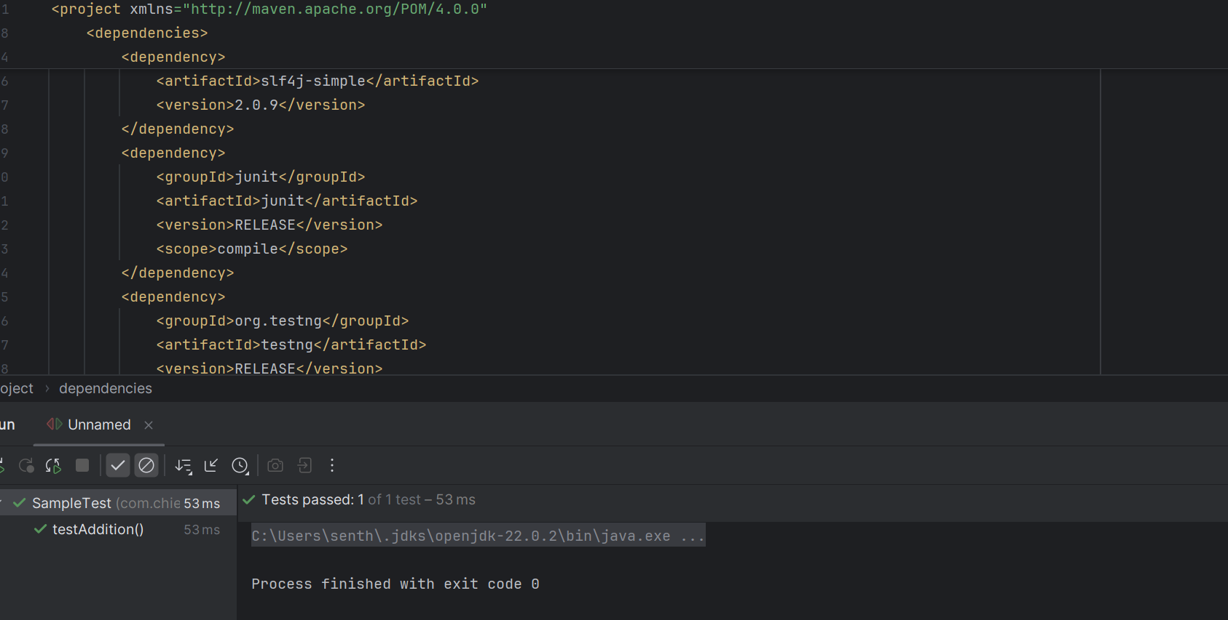

Exercise 3: Assertions
package com.chief.junit;
import org.junit.jupiter.api.Test;
import static org.junit.jupiter.api.Assertions.*;
public class AssertionTest {
@Test
void testAssertions() {
int a = 5;
int b = 5;
int c = 10;
assertTrue(a == b, "a should be equal to b");
assertFalse(a == c, "a should not be equal to c");
assertEquals(10, a + b, "Sum should be 10");
assertAll("Multiple assertions",
() -> assertNotNull(a, "a should not be null"),
() -> assertNotEquals(a, c, "a and c should not be equal")
);
Exception exception = assertThrows(ArithmeticException.class, () -> {
int result = 1 / 0;
});
assertEquals("/ by zero", exception.getMessage());
}
}
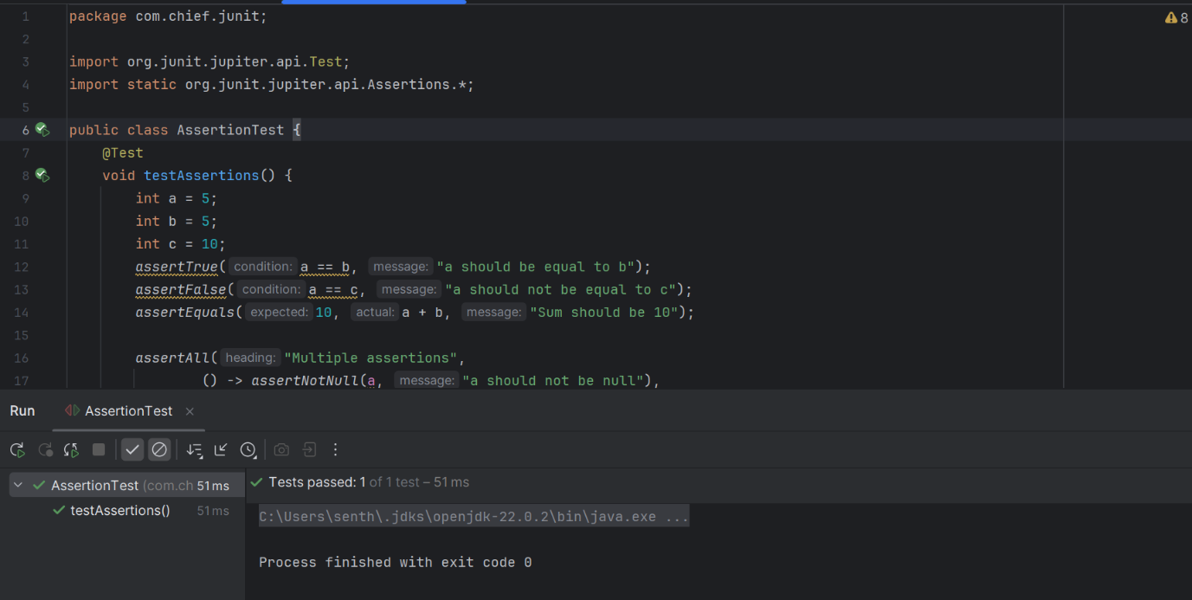

Exercise 4: Arrange-Act-Assert (AAA) Pattern, Test Fixtures, Setup and Teardown Methods in Junit

package com.chief.junit;
import org.junit.jupiter.api.*;
import static org.junit.jupiter.api.Assertions.*;
class CalculatorTest {
Calculator calculator;
@BeforeEach
void setup() {
calculator = new Calculator();
}
@Test
void testAdd() {
int result = calculator.add(5, 3);
assertEquals(8, result);
}
@Test
void testSubtract() {
assertEquals(2, calculator.subtract(5, 3));
}
@AfterEach
void teardown() {
calculator = null;
}
}
